Annex 2 – Extracts from the coding trees
(phase 1 and phase 3)

- Phase 1 : interviews with « involved » GPs

- Phase 1, overview 1 : access and continuity of care, overview (« involved » GPs)
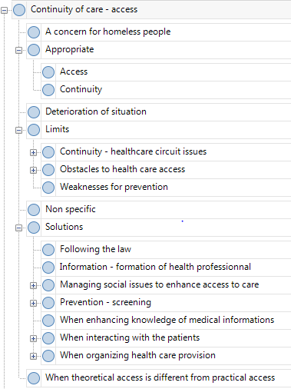

- Phase 1, overview 2 : How the involved GPs care for HP
(« involved » GPs)

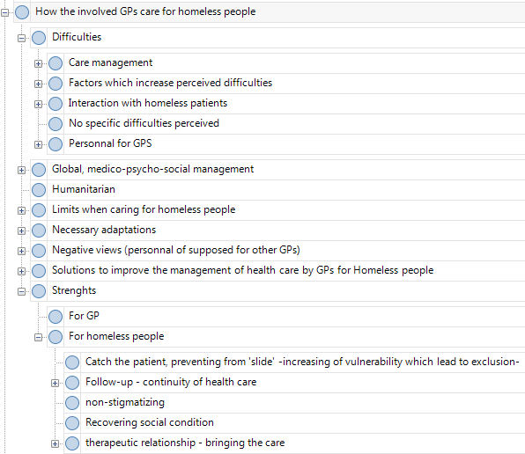

- Phase 1, Focus 1 -Difficulties when caring for HP - views of « involved » GPS

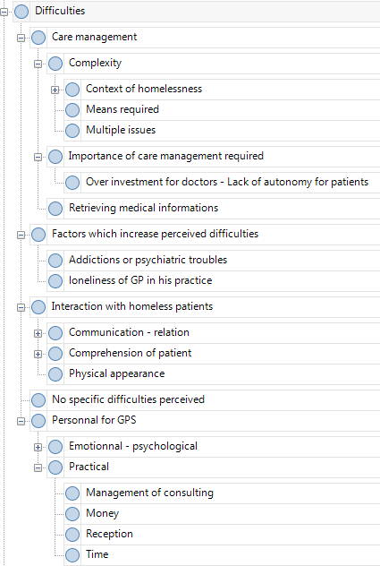

- Phase 1, focus 2 – Limits when caring for homeless people
(“involved GPs”)
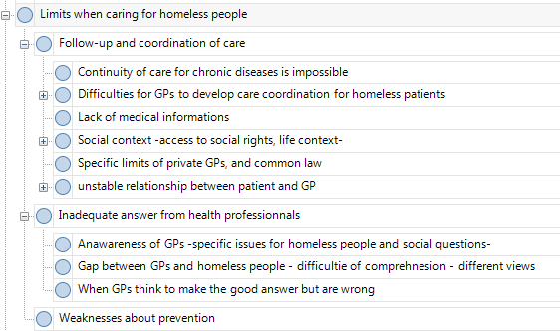

- Phase 1, Focus 3 - GPs may adapt their practice when they care for HP (“involved GPs”)
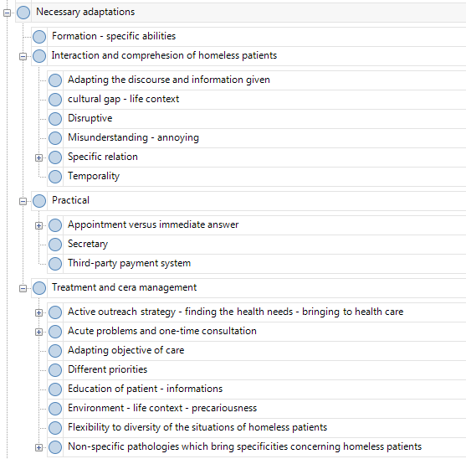

- Phase 1, focus 4 - The importance of a global medico-psycho-social care (“Involved GPs”)
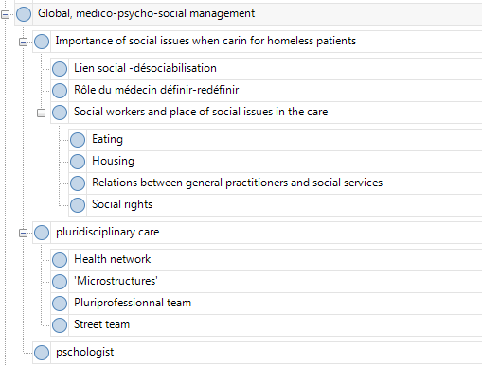

- Phase 1, focus 5 - Solutions to improve the management of health care by GPs for homeless people (« involved GPs »)
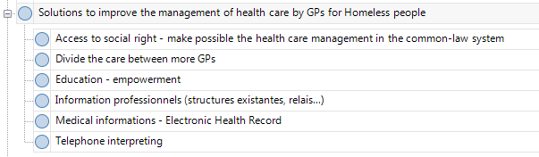

- Phase 3 : interviews with « standard GPs »
- Phase 3, Standard GPs and HP - coding tree overview
(« standard GPs »)
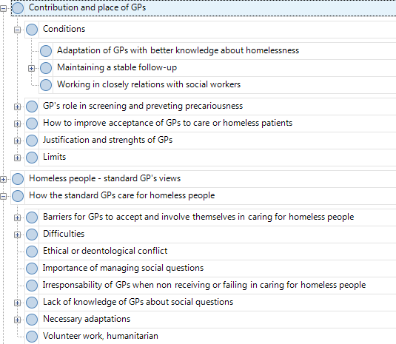

- Phase 3, focus 1 - positive and negative views of “standard” GPs about homeless people
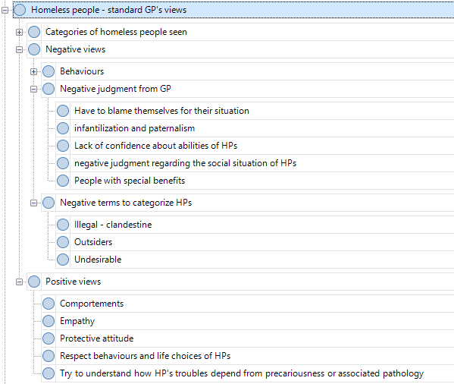

- Phase 3, Focus 2 - the follow-up condition, positive factors (« standard » GPs)

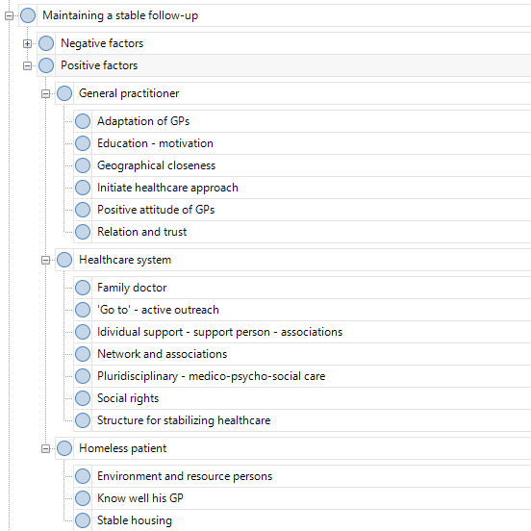

- Phase 3, focus 3 - the follow-up condition, negative factors (« standard » GPs)
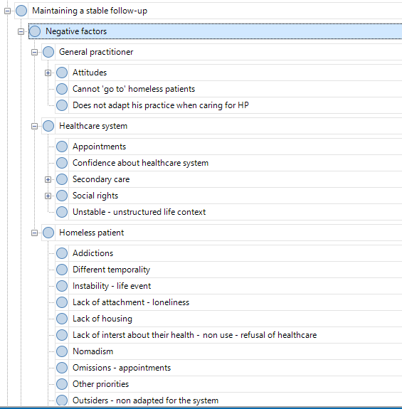

- Phase 3, Focus 4 - How GPs have to adapt their practice
(« standard » GPs)
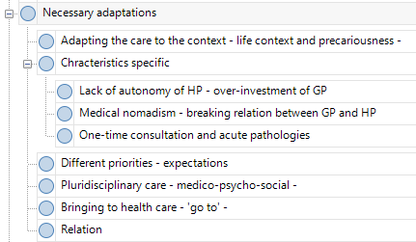

- Phase 3, Focus 5 - difficulties when GPs care for homeless people (« standard » GPs)
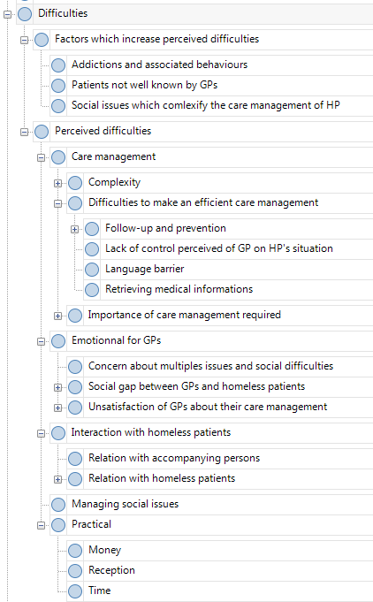

- Phase 3, Focus 6 - organizational solutions to improve involvement and effectiveness of GPs (standard GPs)
